Spike: Spike 3
Title: Debugger Use

Author: Rachel McQueenie 696737x

Goals / deliverables:
Use the debugging tool of a chosen IDE to fix the issues in the provided code on Blackboard. Deliver:
- Fixed Code
- Spike Outcome Report

Technologies, Tools, and Resources used:
- Windows 8
- Visual Studio 2012
- Spike 3 code on Blackboard
- WinMerge

Tasks undertaken:
- Whenever I would come across an error, I would first try to resolve it by going through the code and trying to decipher the issue logically.
- If that did not work, I would place a breakpoint near that are of the code and Step Through, looking at the watches and other details to see if they provided more information.
- These were the issues I discovered, and resolving them allowed the program to run, along with screenshots of the changes. The original code is on the left, while the fixed code is on the right:

  - Fixed issue with initialising L
    - The linked list was only being declared and not initialised
  - Fixed issue with insertNodeAfter()
    - Recursive function lead to trying to repetitively add a single Node to the List (infinite loop).
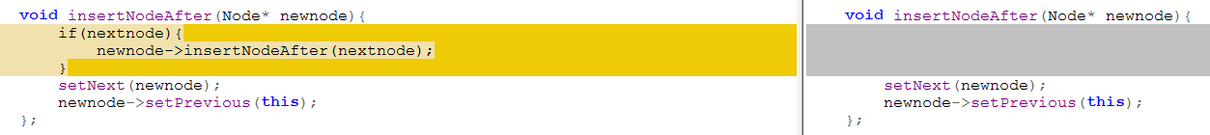
  - Fixed issues with Print
    - N wasn't pointing to the first node
    - This may have been an issue with my compiler, but the while loop was causing an error, so to get around that I used a for loop.
    - N wasn't getting changed to the next node, so that needed to be resolved as well.

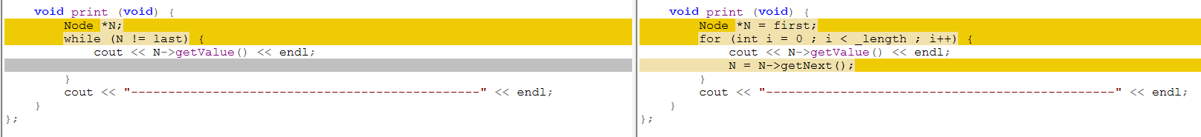

  - Fixed issue with insertNodeBefore()
    - Recursive function lead to trying to repetitively add a single Node to the List (infinite loop).
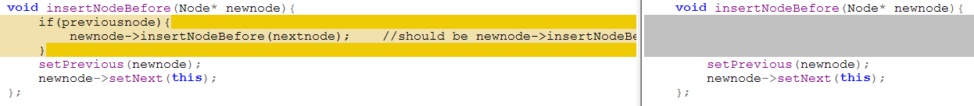
  - Fixed issues with drop()
    - Dropping the nodes was not reducing the length, so made it so it would.
    - While loop was again causing issues, so changed to a for loop
    - Node N wasn't getting set to the next node, so made it so it would
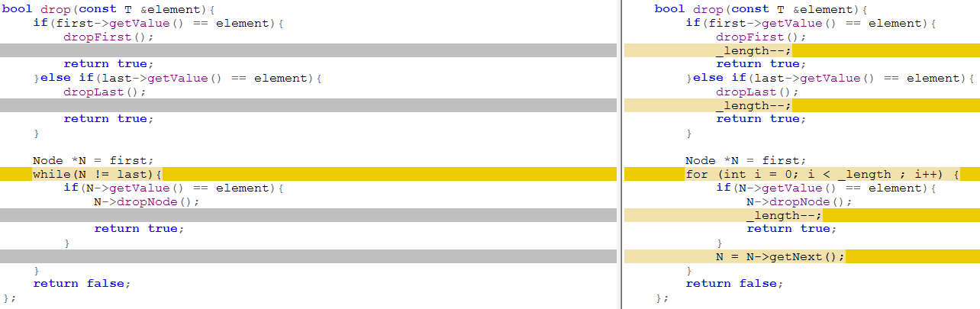
  - Fixed issues with dropNode()
    - DropNode() wasn't properly handling setting the previous and next nodes when it was removing the first and/or last node. I overloaded the function with two bool parameters (isFirst, isLast) to add this functionality.
    - Also changed the dropNode() calls in dropFirst(), dropLast() and the DoubleLinkedList destructor to reflect this
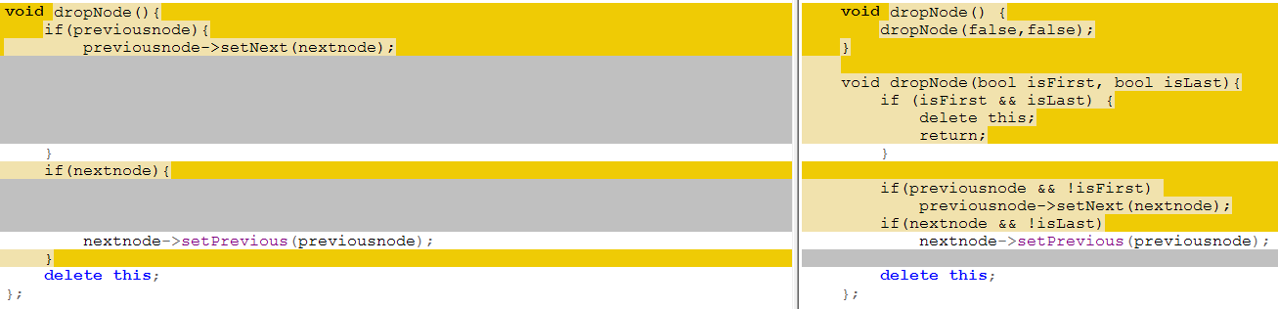

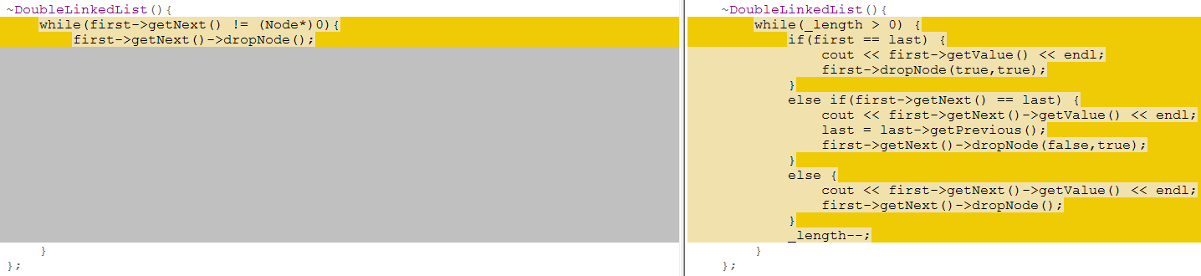
- Added input. Not necessary but just there to see the output of the program.
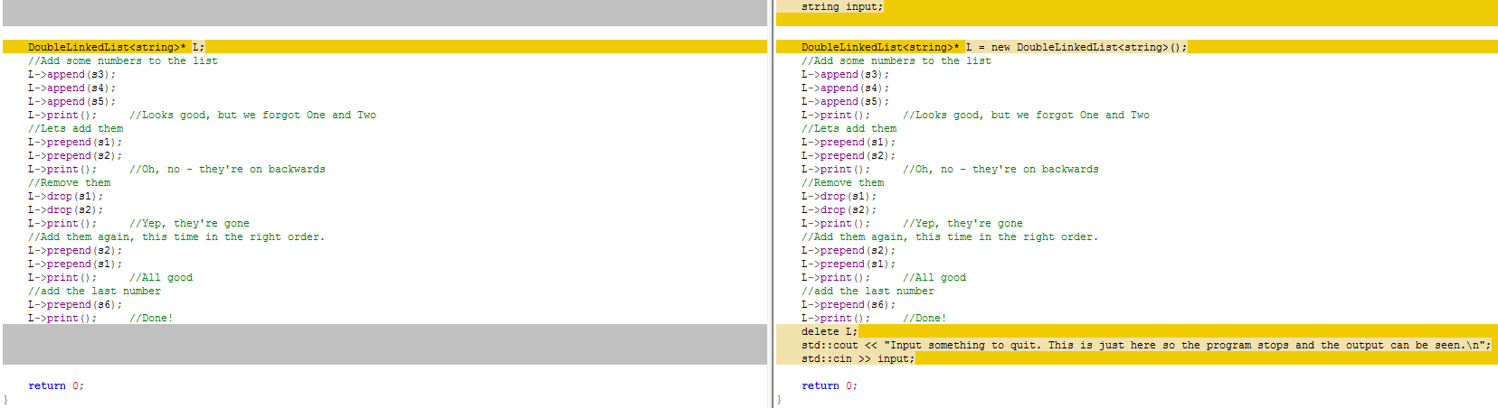
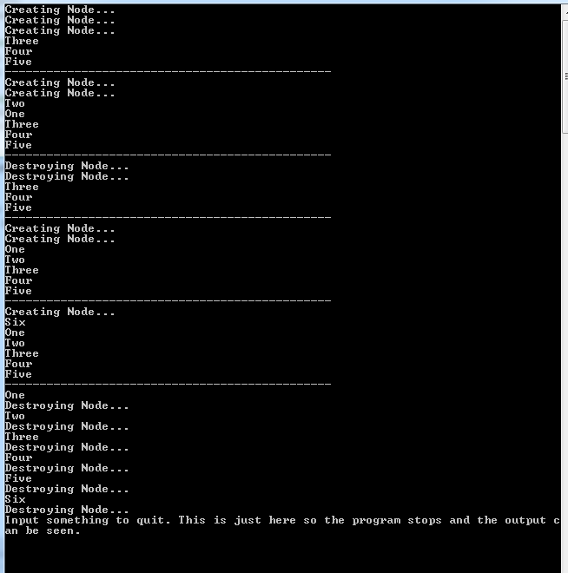
- Opened the original and fixed code files in WinMerge and compared the changes
What we found out:
The debugger is a useful tool when programming games as it makes it possible to step through your program while it runs so you can see what the code is doing at a point in time, opposed to having the whole program run and only seeing the effects of the code after it has run or crashed. This can help discover bugs within the code before they have their effects so that they can be fixed on the spot and avoid further problems in the future.

